**Disabling Amazon GuardDuty**

### Introduction

Amazon GuardDuty incurs [costs for analyzing the variety of data sources](https://aws.amazon.com/guardduty/pricing/) that it monitors. If you no longer need the proactive threat detection provided by GuardDuty, you can either suspend or disable it to stop accumulating costs. If you disable GuardDuty, any findings that were discovered by GuardDuty will be lost. In practice, you are encouraged to back up any findings you want to preserve before disabling GuardDuty.

In this Lab Step, you will disable GuardDuty because you will not need to preserve any findings or activate GuardDuty later.

### Instructions

1. In the GuardDuty Console, click on **Settings**in the left sidebar:

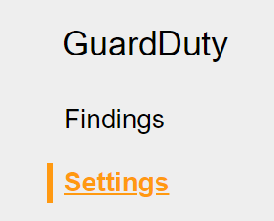

2. Under **Suspend GuardDuty**, click on **Disable GuardDuty**:

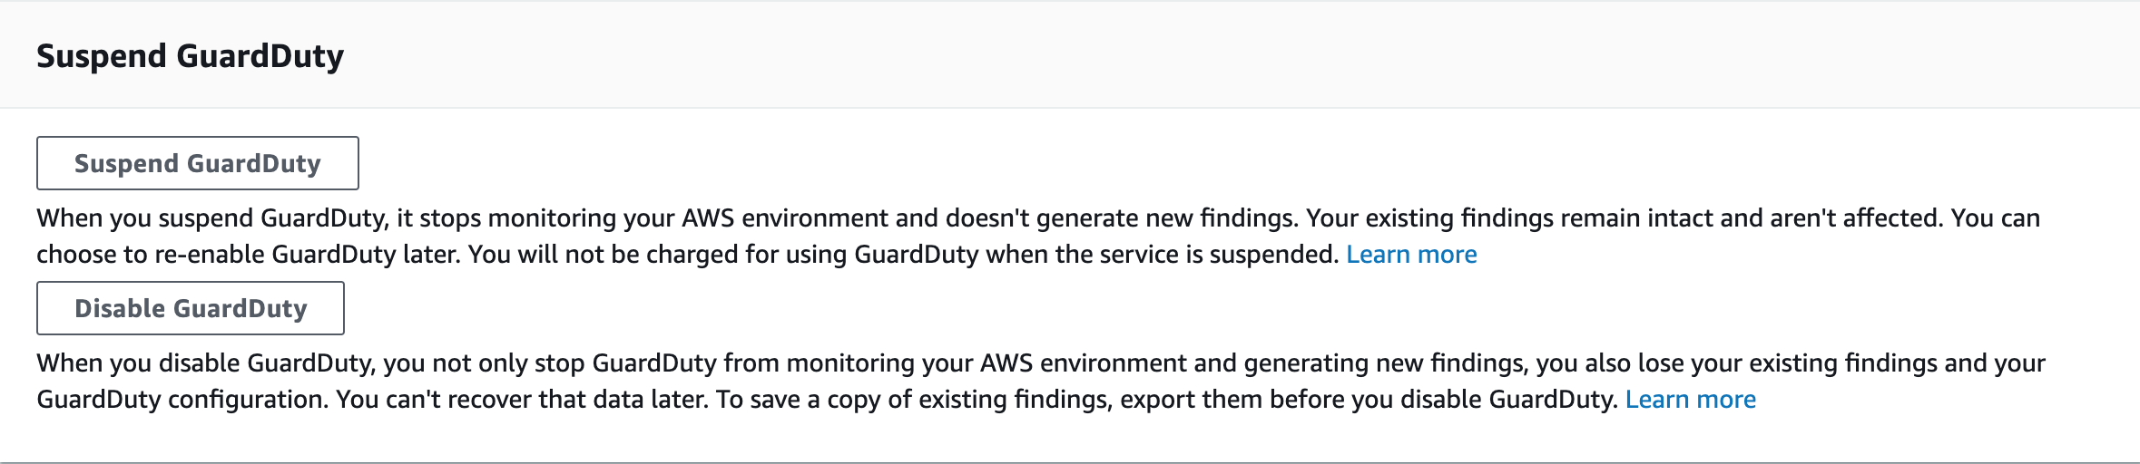

3. Click **Disable** in the confirmation dialog:

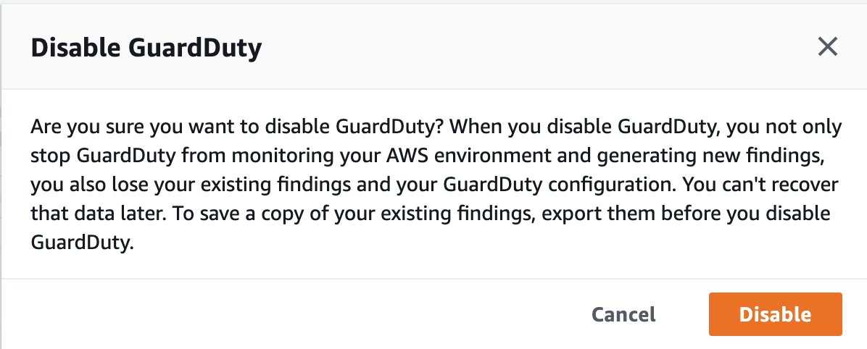

You are presented with the GuardDuty welcome page when the operation is complete.

### Summary

In this Lab Step, you disabled GuardDuty to stop accumulating threat analysis costs and to remove any trace of previous findings.

VALIDATION CHECKS

**1Checks**

Check again

**Disabled GuardDuty**

Check if GuardDuty has been disabled.

Amazon GuardDuty